**Cloud Trail & Cloud Watch**

**Summary : AWS CloudTrail** is used to record and track user and API activity in an AWS account. It logs who performed an action, what action was taken, when it occurred, and from where, making it mainly useful for security, auditing, and compliance. **AWS CloudWatch** is used for monitoring and observability, collecting metrics, logs, and events to track the performance and health of resources and applications, and it allows setting alarms and automated actions.

* Enable CloudTrail monitoring and store the events in S3 and CloudWatch log events  
  Click on create trail and provide trail name and use existing s3 bucket if you have or create a new one and click on next   
  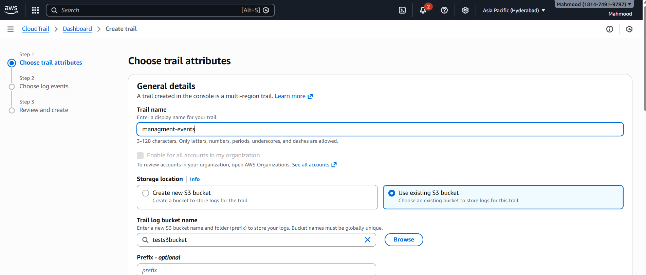   
  And then select Management events and click on Next and create a trail  
  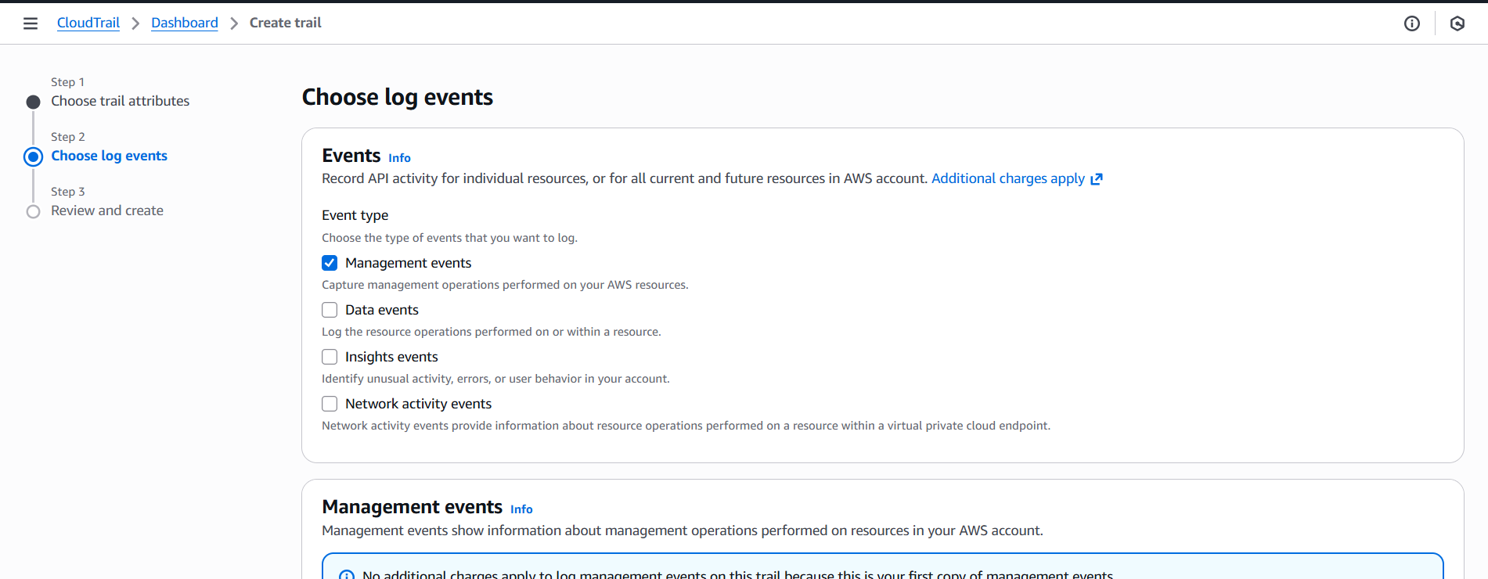  
  Click on edit in cloud watch logs and enabled it the click on save changes  
  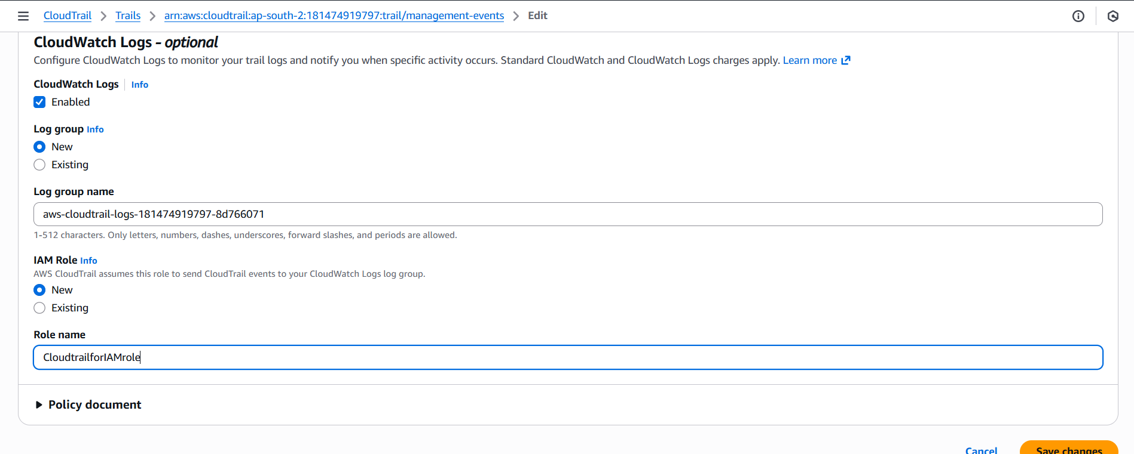  
  The trail is successfully created  
  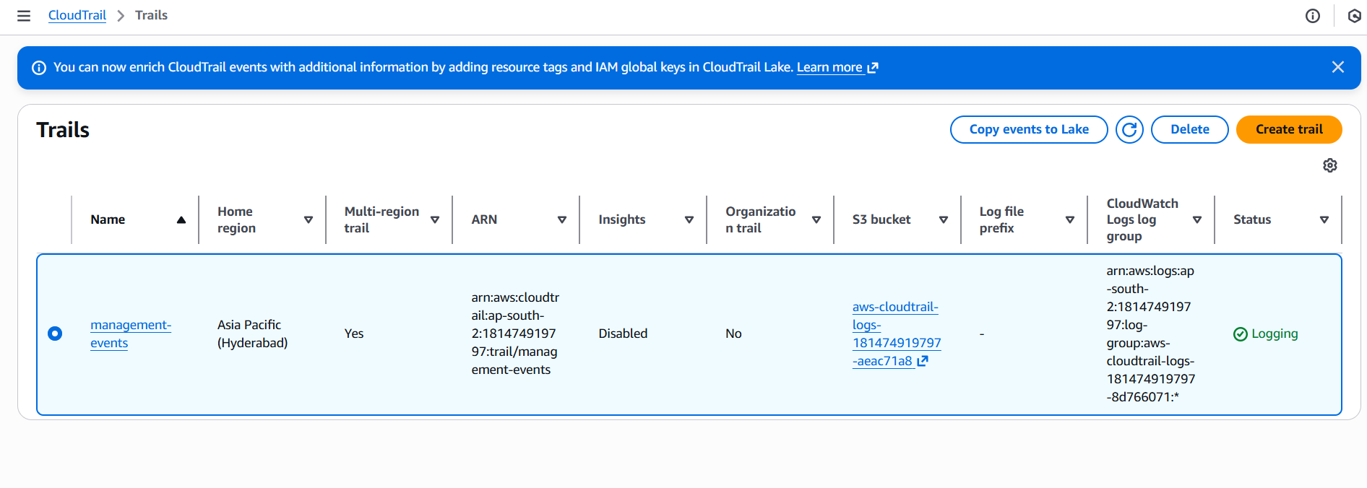
* Enable SNS for CloudTrail to send alerts via email  
  Search SNS and click on next step  
  And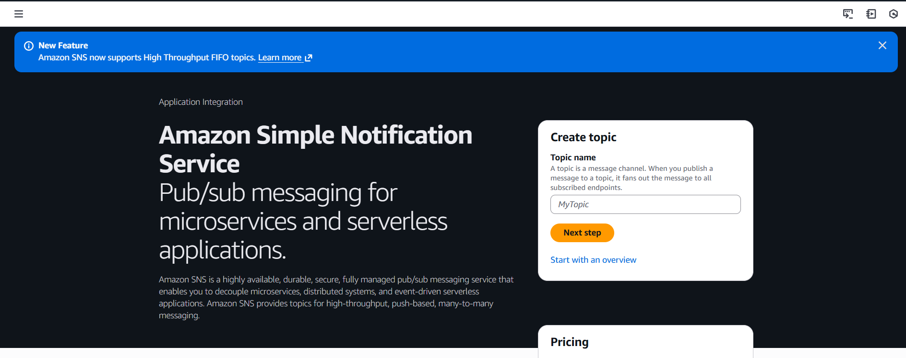  
  Then create topic select as standard and provide the name then click on create topic  
  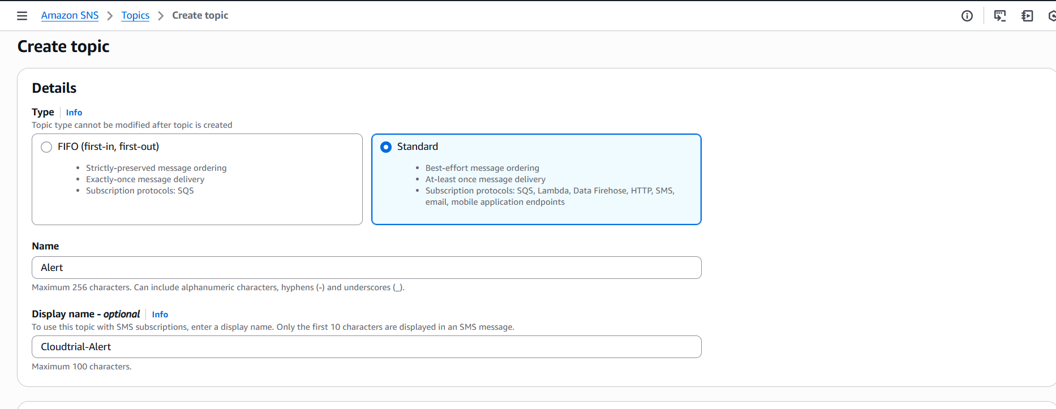  
  The topic is created successfully now we need to send alerts via email, click on create subscription  
  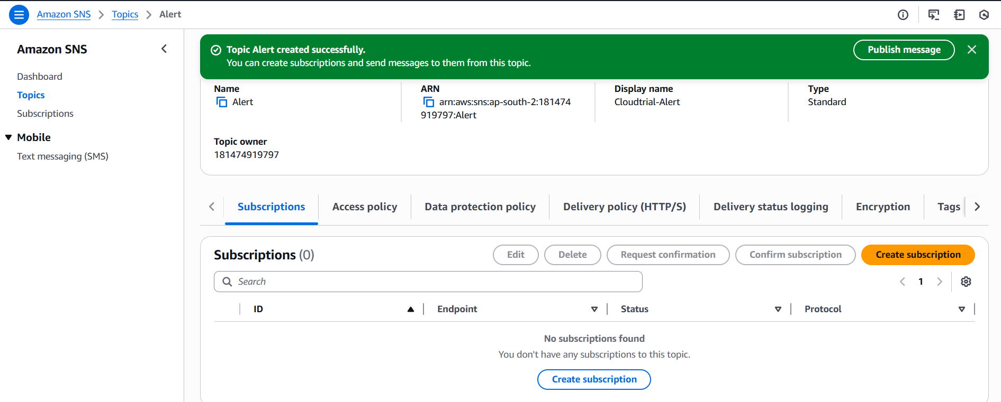  
  And provide protocol type as email and add the email address then click on create subscription  
  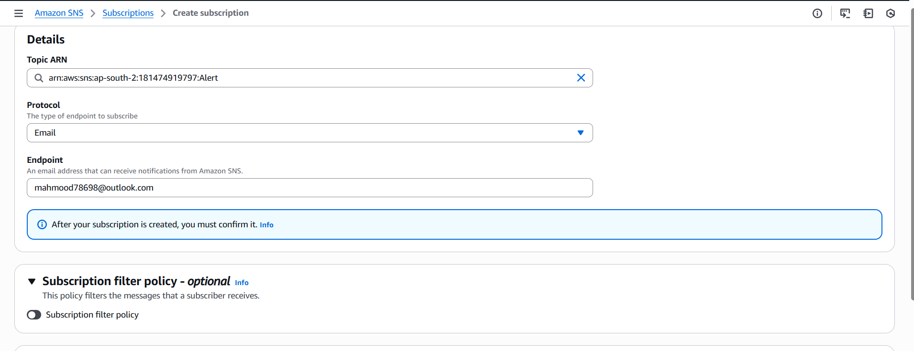  
  Subscription is created is successfully and status is pending confirmation.  
  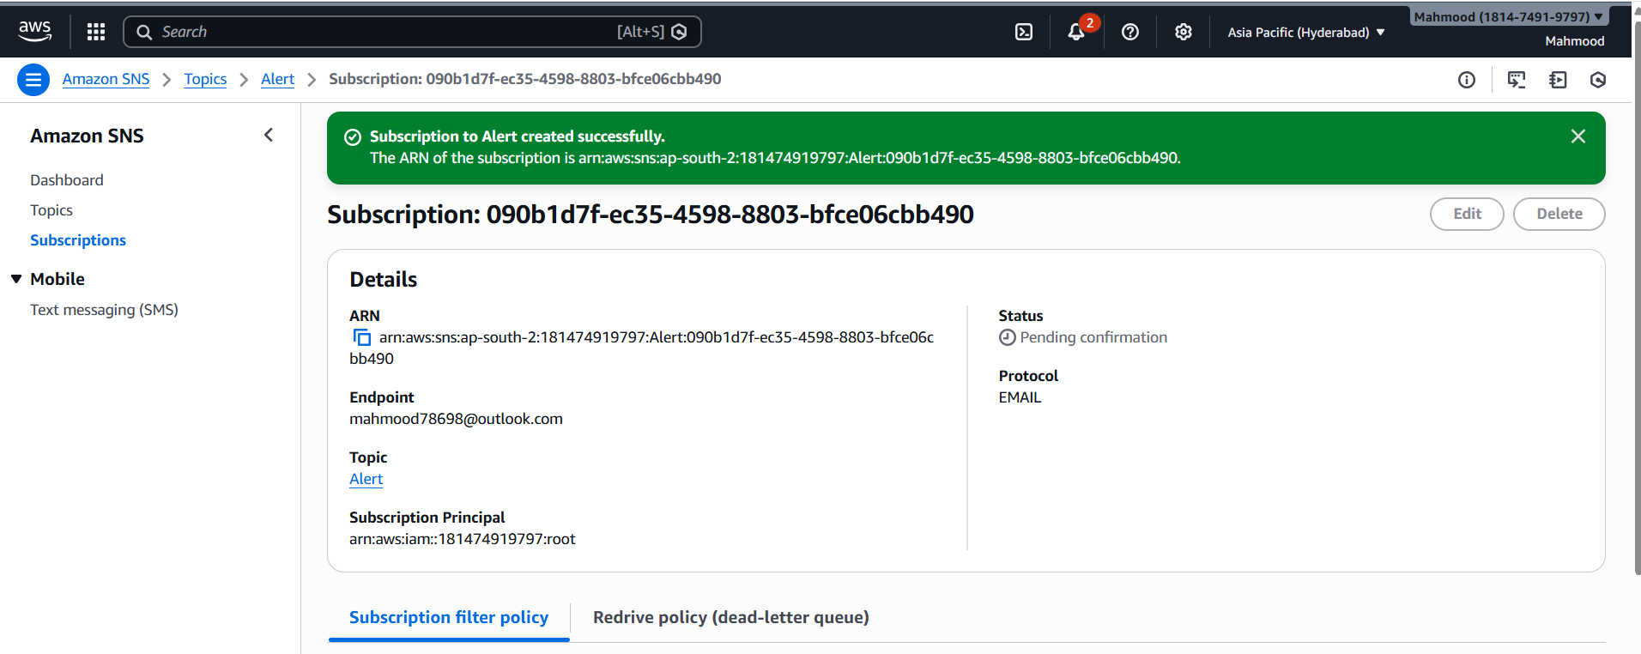  
  We get an email to confirm subscription click on it and subscription will confirmed  
  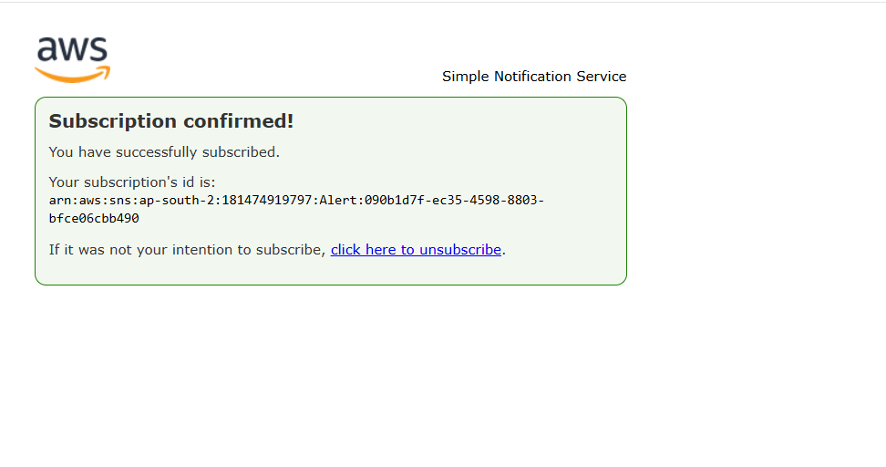  
  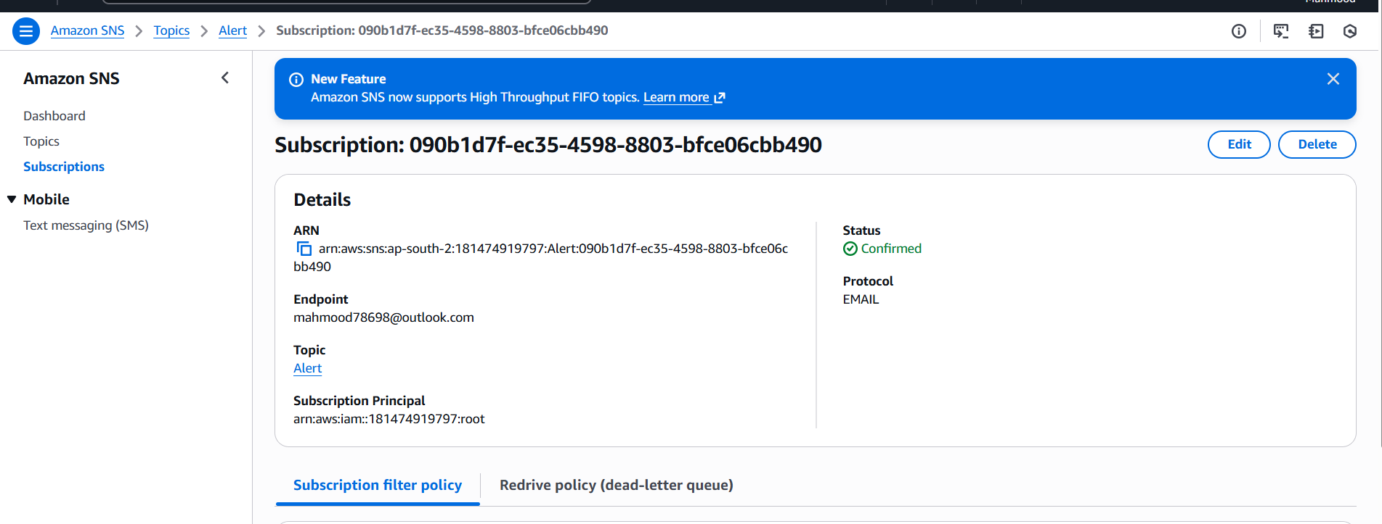  
  The following alert alarm is created   
  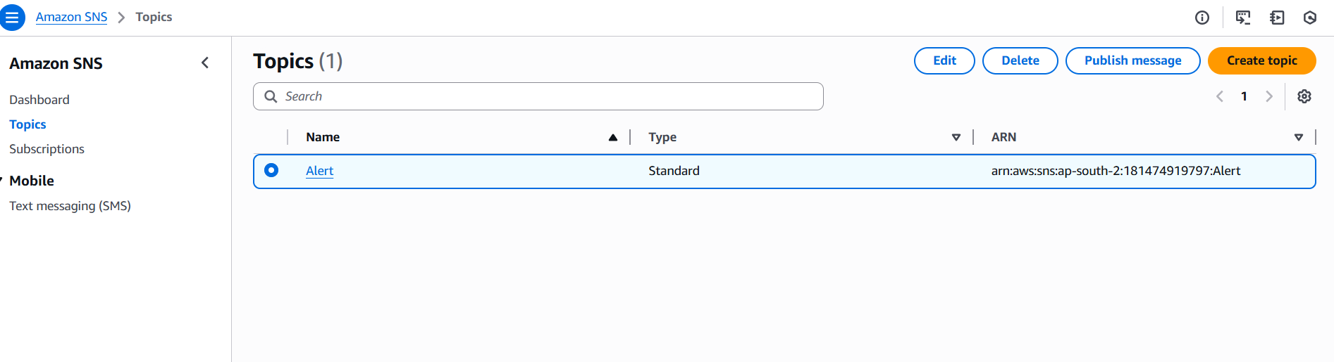
* Configure CloudWatch monitoring and record the CPU utilization and other metrics of EC2  
  Launch one instance to monitor cpu utilization and click on monitoring and enable and confirm  
  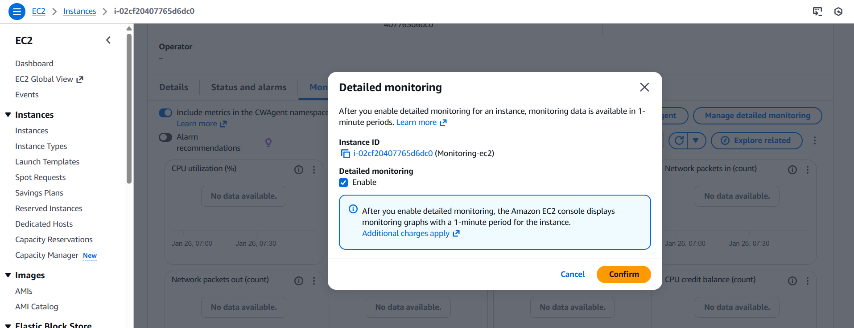  
  And refresh it then see the cpu utilization  
    
  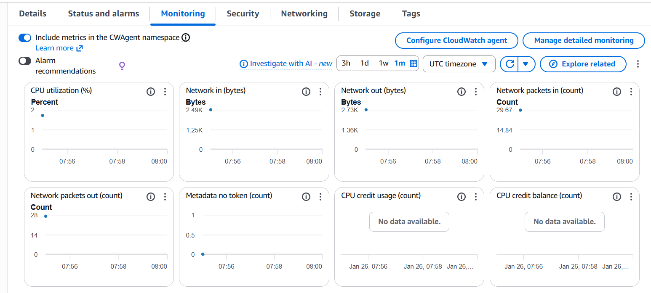
* Create one alarm to send an alert to email if the CPU utilization is more than 70 percent   
  First we need to add CPU utilization by adding load Search cloud watch and click on create dashboard  
  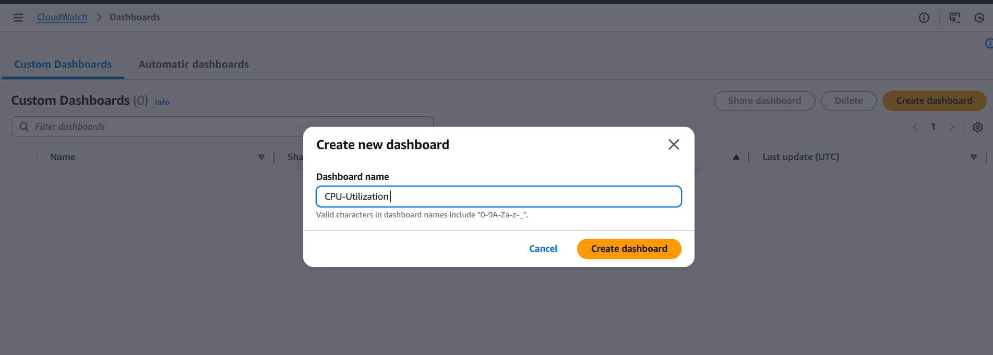  
  And select widget as Number and click on Next  
  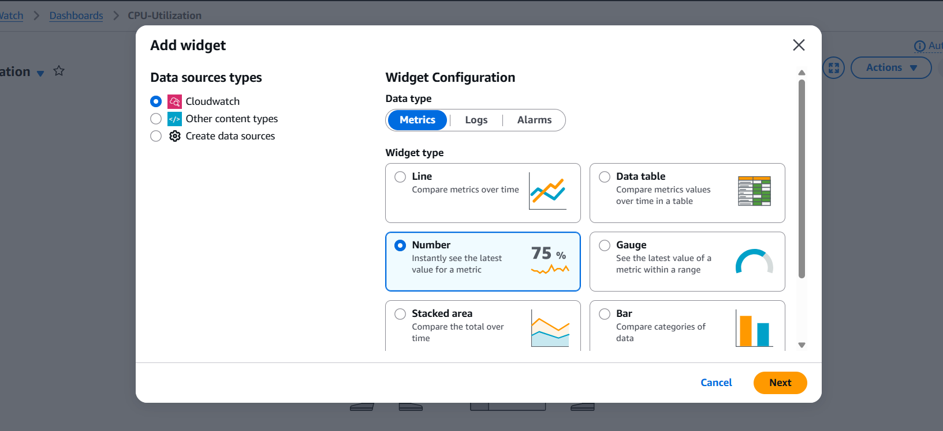  
  Add metric graph and then copy the ec2 instance number and paste it then select CPU Utilization and click on create widget  
  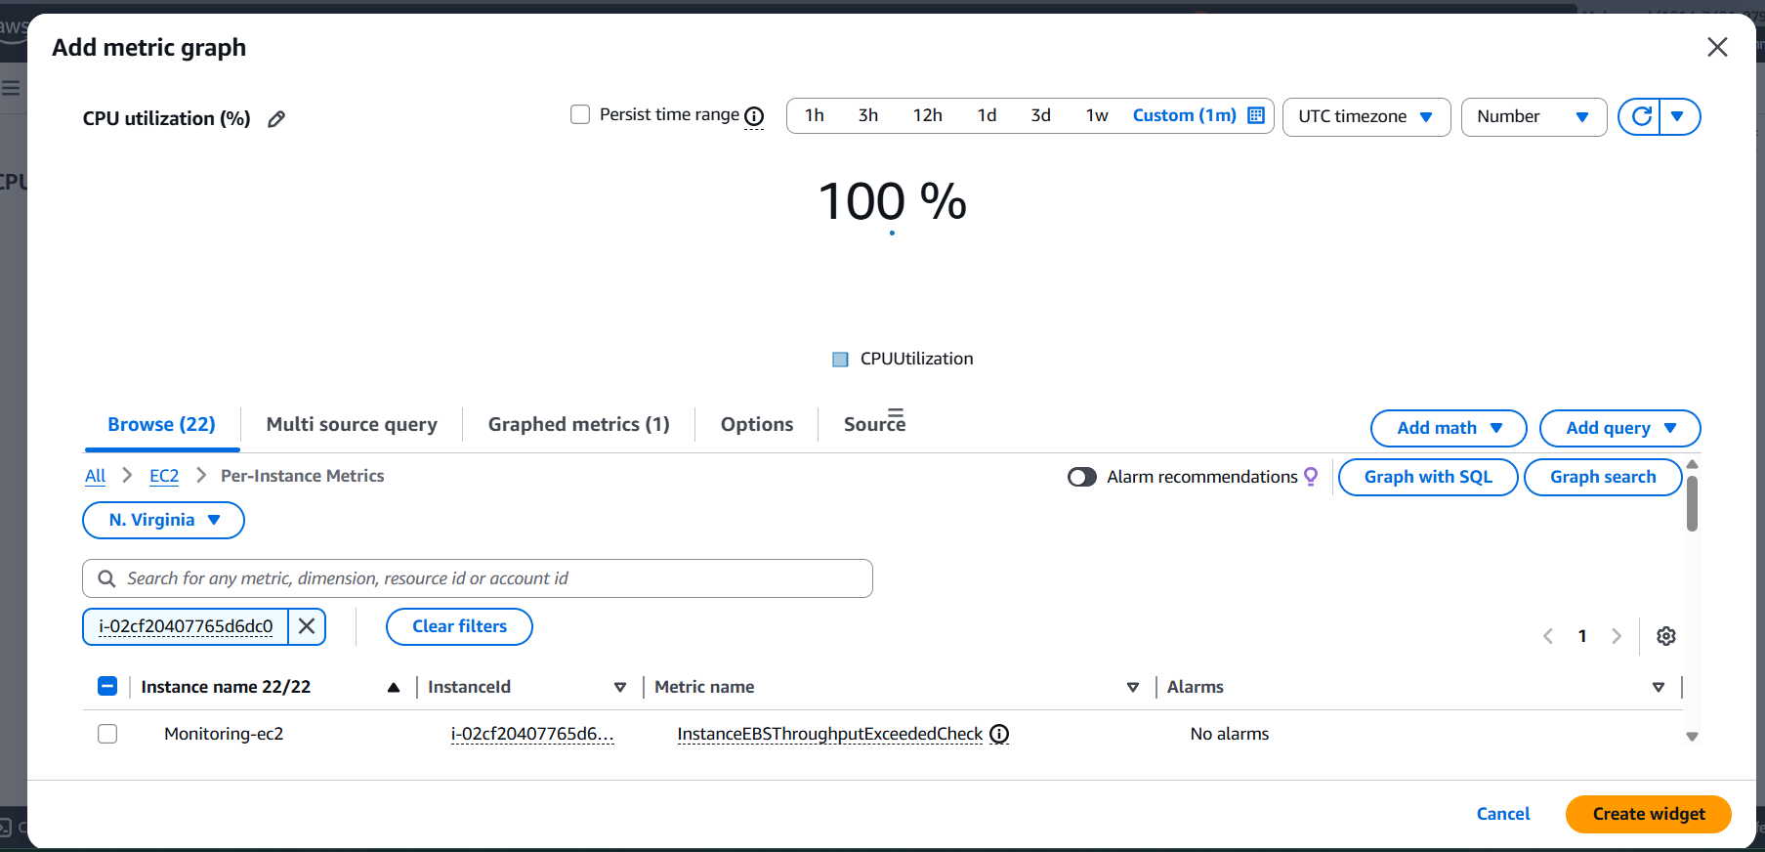  
  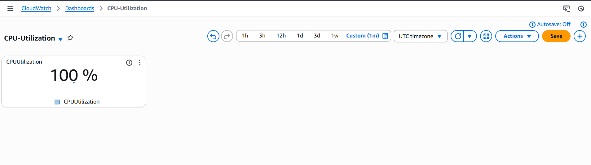  
  Now we need to create an alarm to send to alert email, click on create alarm and select matric and add ec2 instance id and select CPU Utilization   
  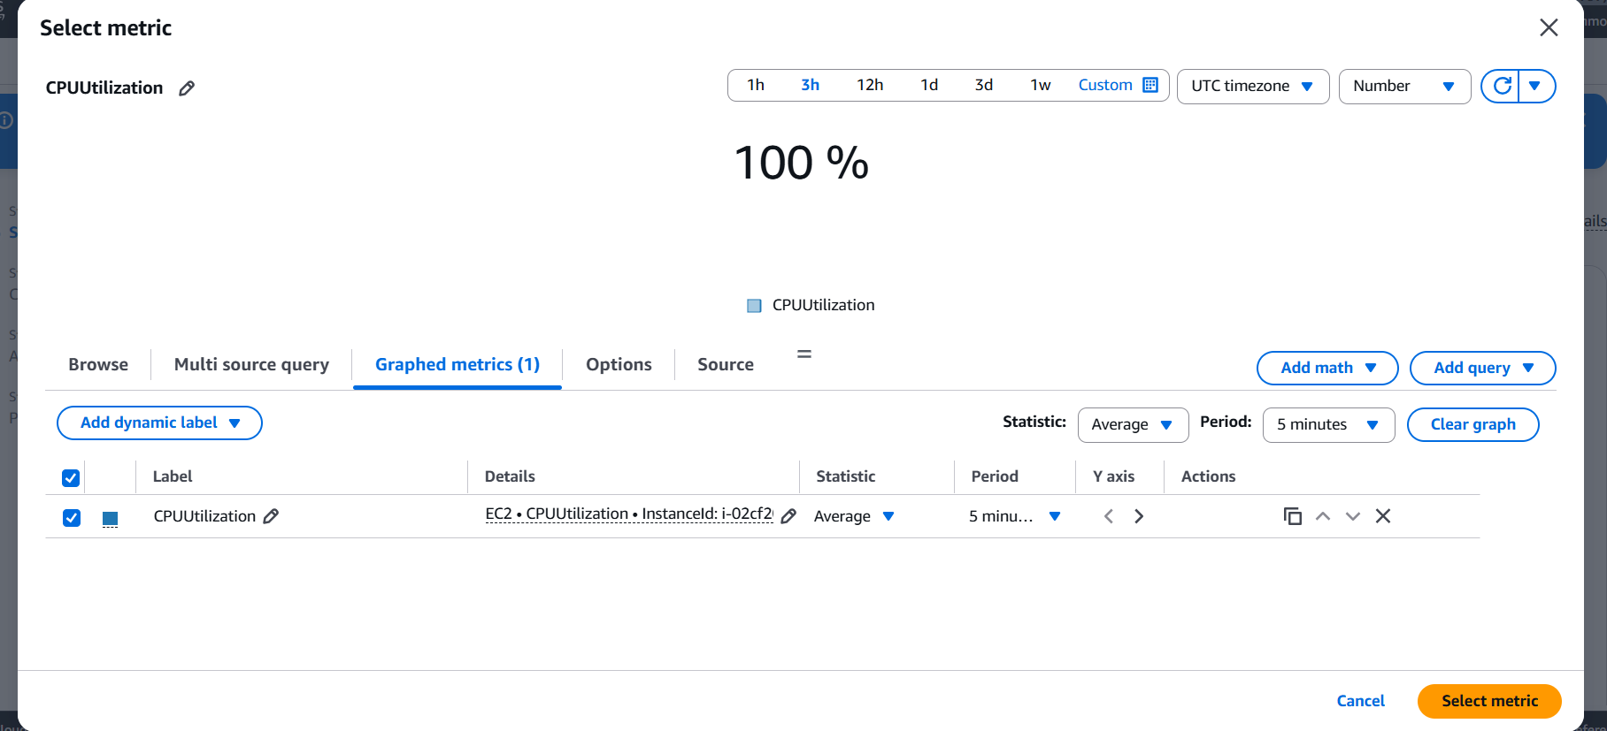  
  And select conditions as Greater/Equal and threshold value as 70 then click on next  
  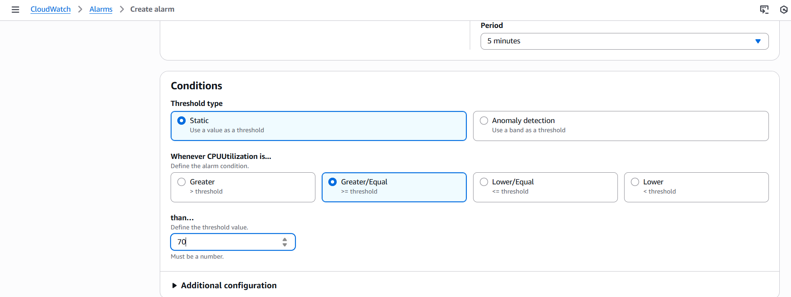  
  Configure actions as In alarm and select an existing SNS and click on Next  
  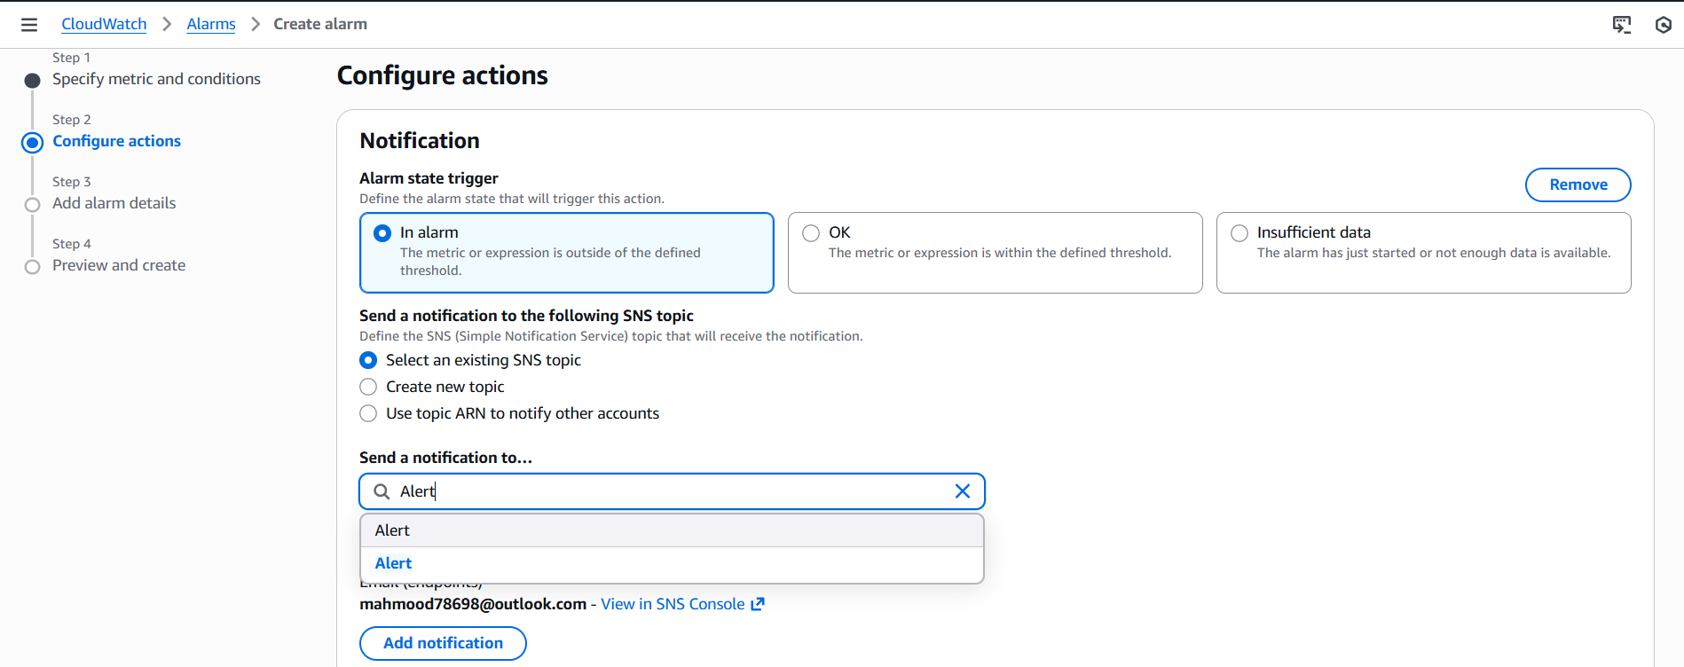  
  And add alarm name  
  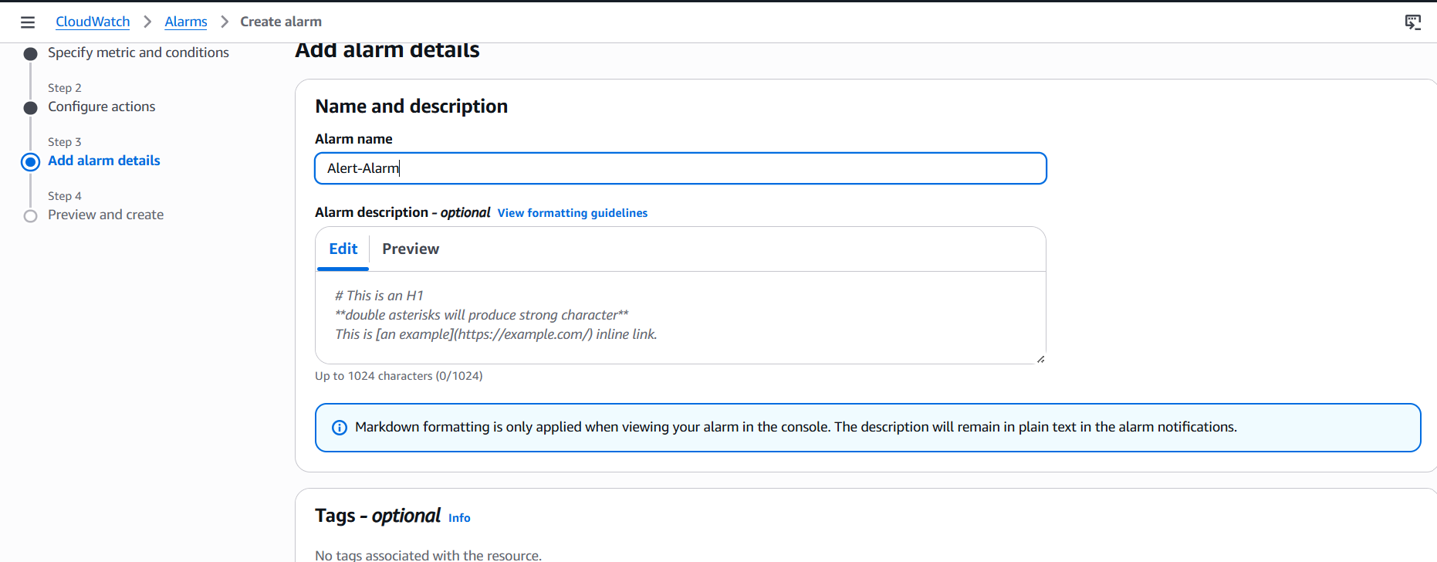  
  Alarm is successfully created   
  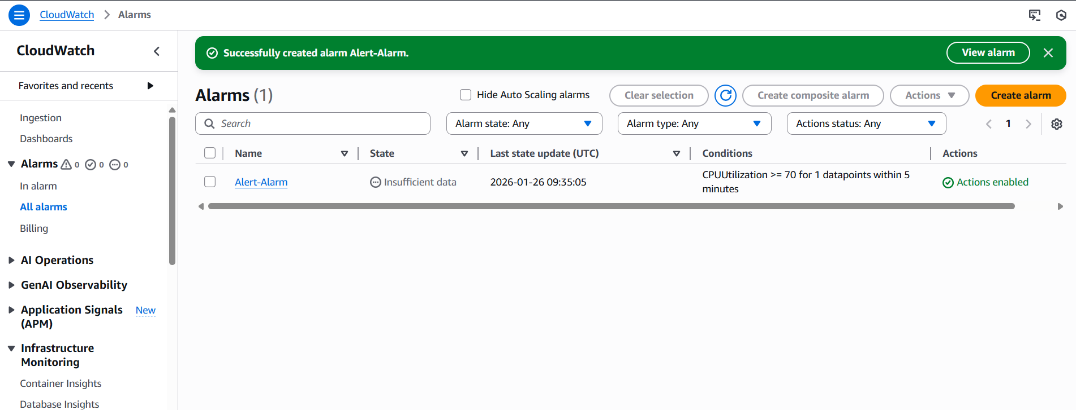  
  Email received  
  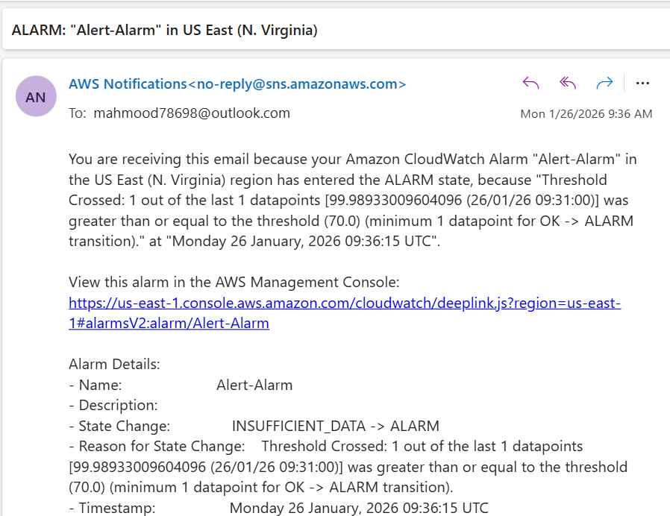
* Create a Dashboard and monitor the Tomcat service whether it is running or not and send the alert  
  Launch one ec2 instance and connect it with ssh and install Tomcat  
  Install Java  
  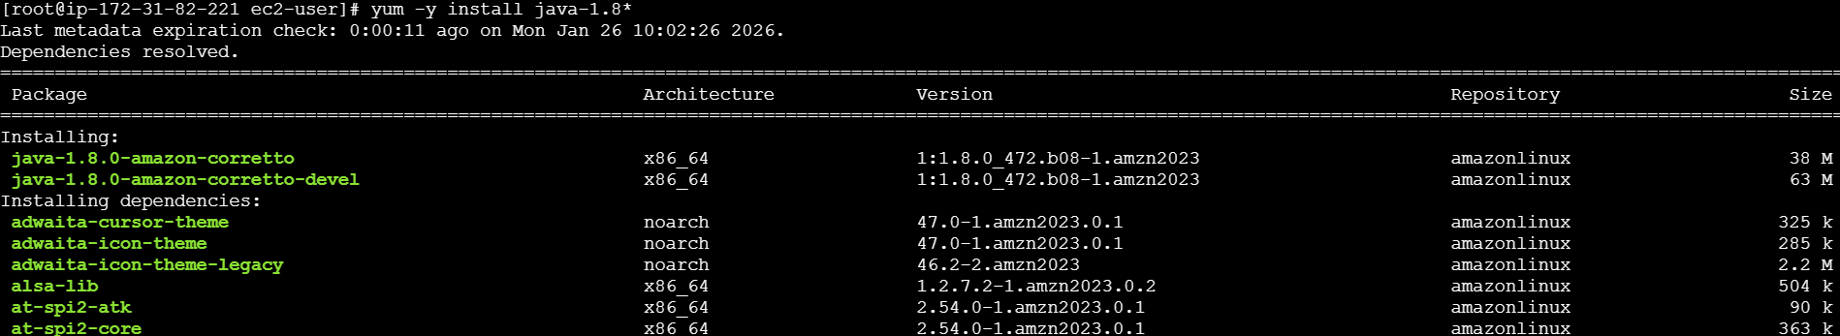  
  Download Tomcat 9 and Tar the file also startup the file   
  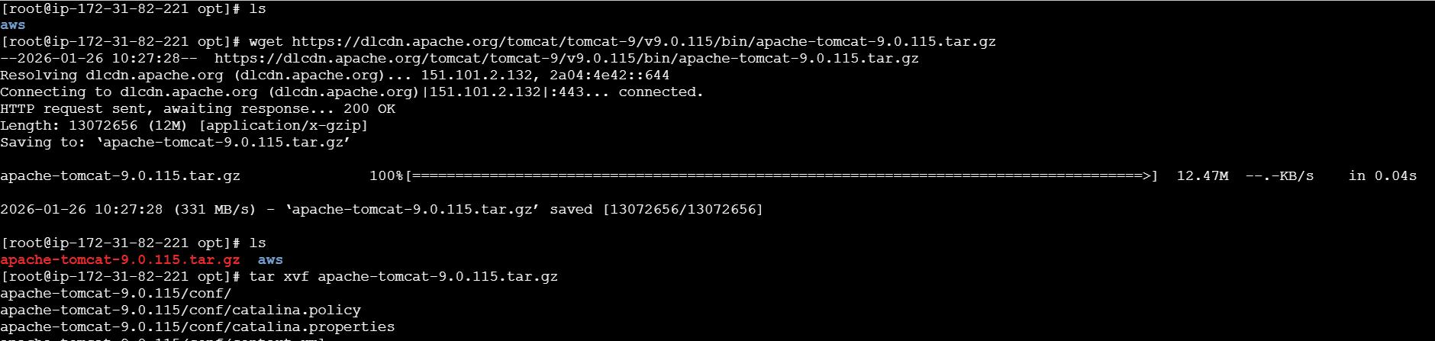  
  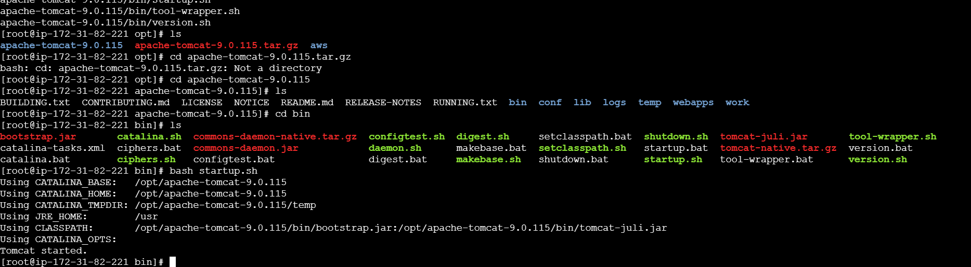  
  Tomcat started and check it on browser publicip:8080  
  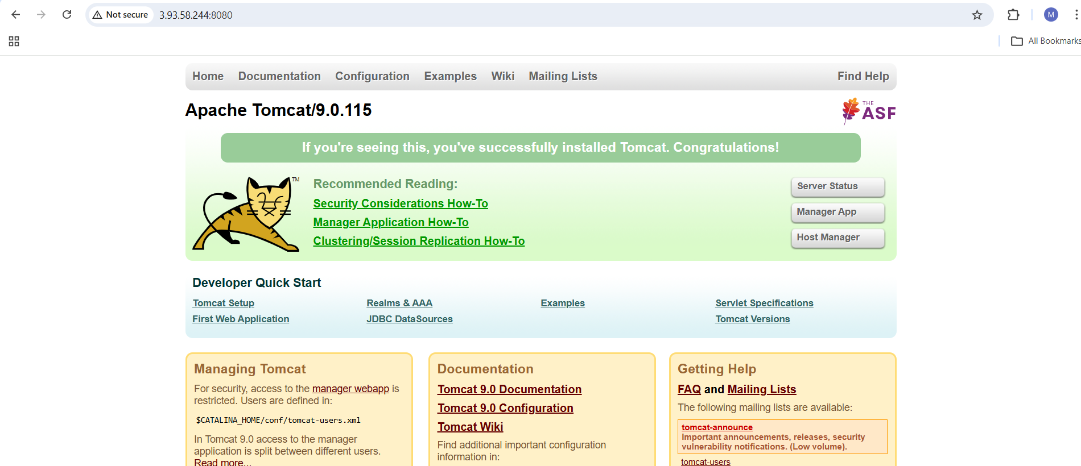  
  Now we need to add the metrics to send an email   
  vi monitoring bash and add the script that we have on file and change the version and region   
  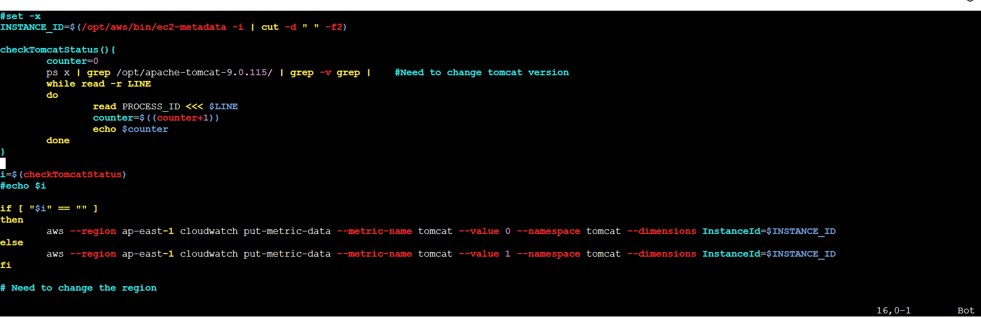  
  Now go to cloud watch create dashboard and add tomcat   
  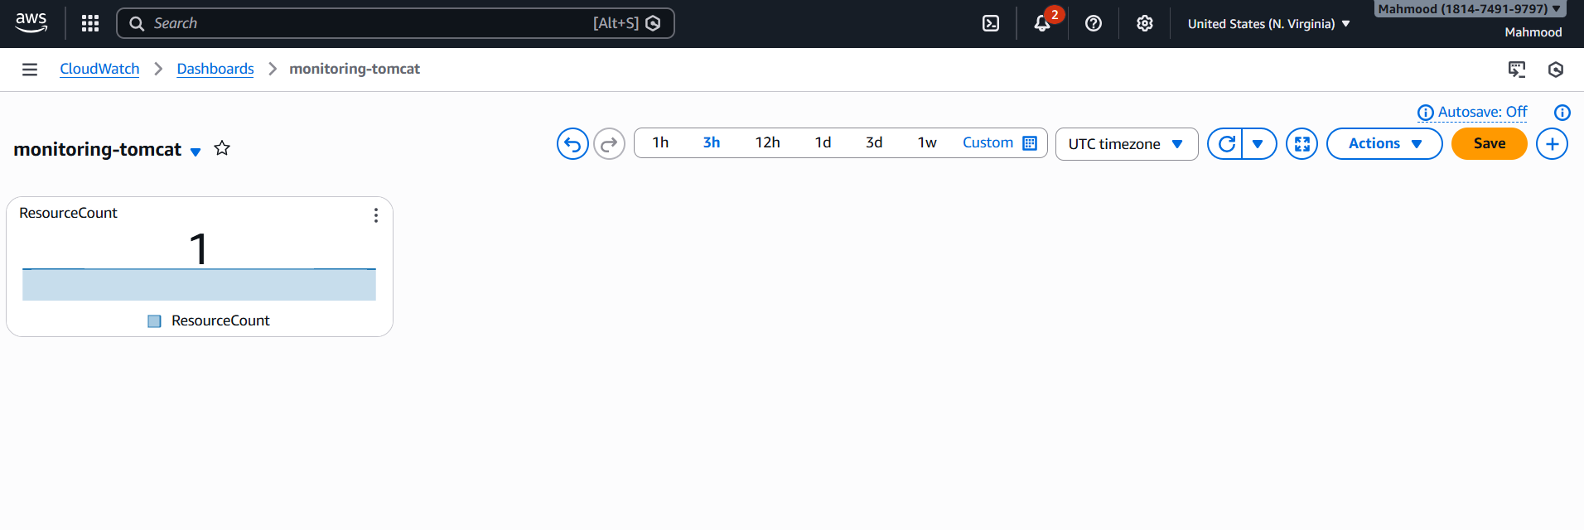  
  Now we need to create alarm, create alarm and select metrics and provide the number  
  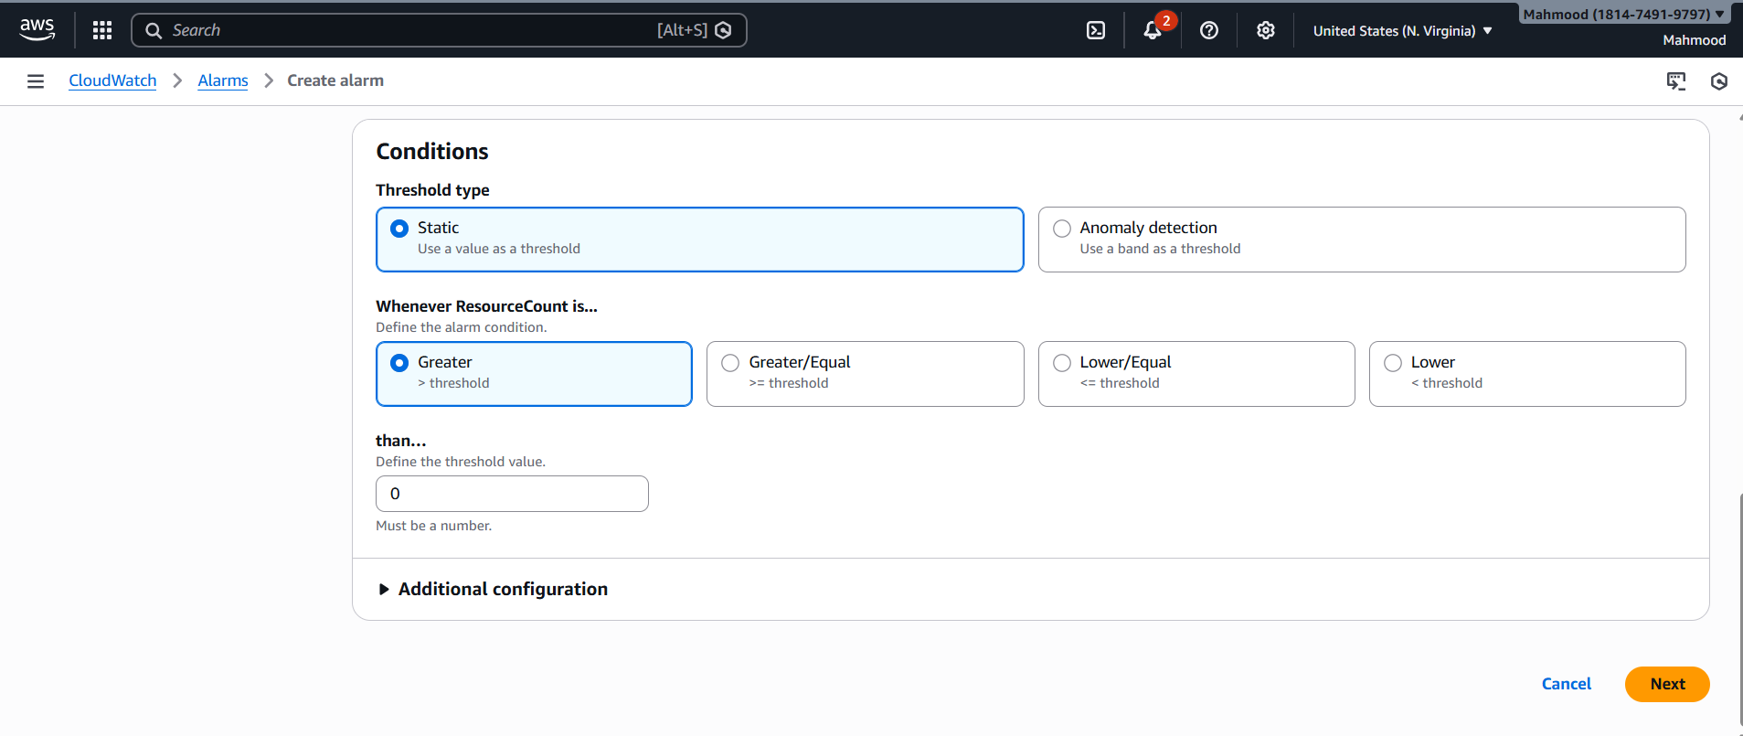  
  And select as Ok and existing SNS  
  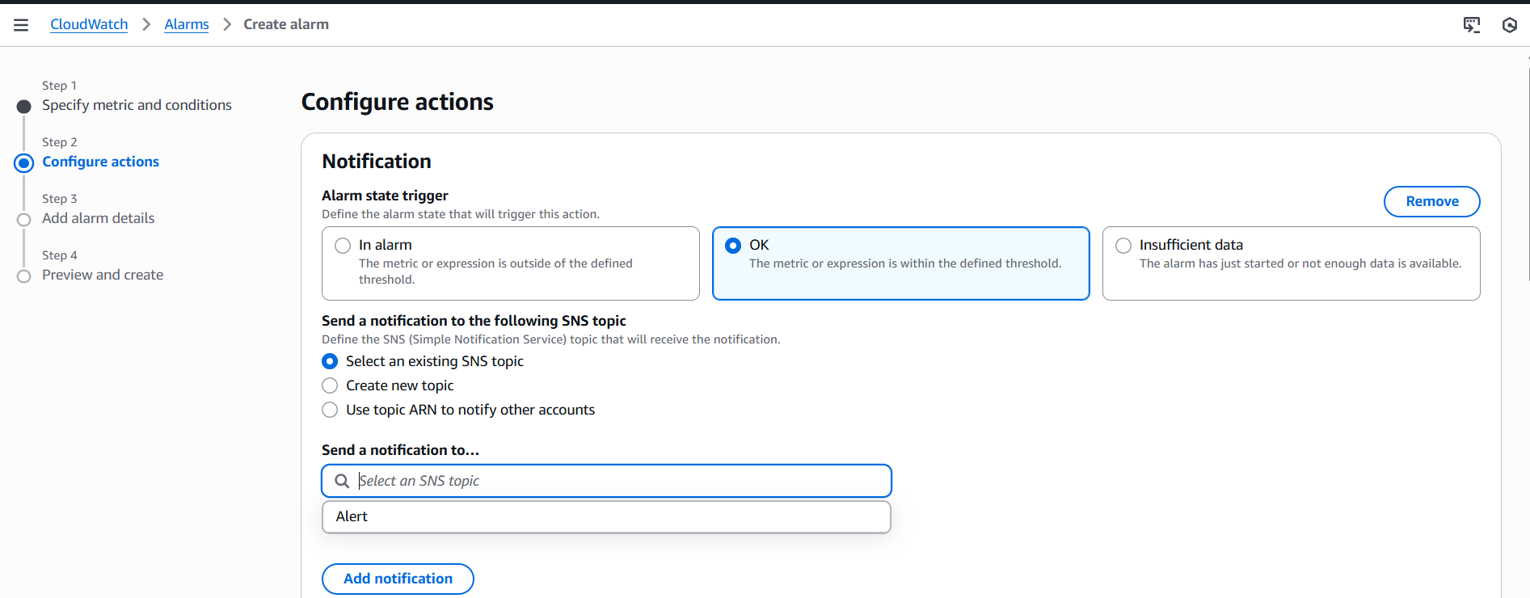  
  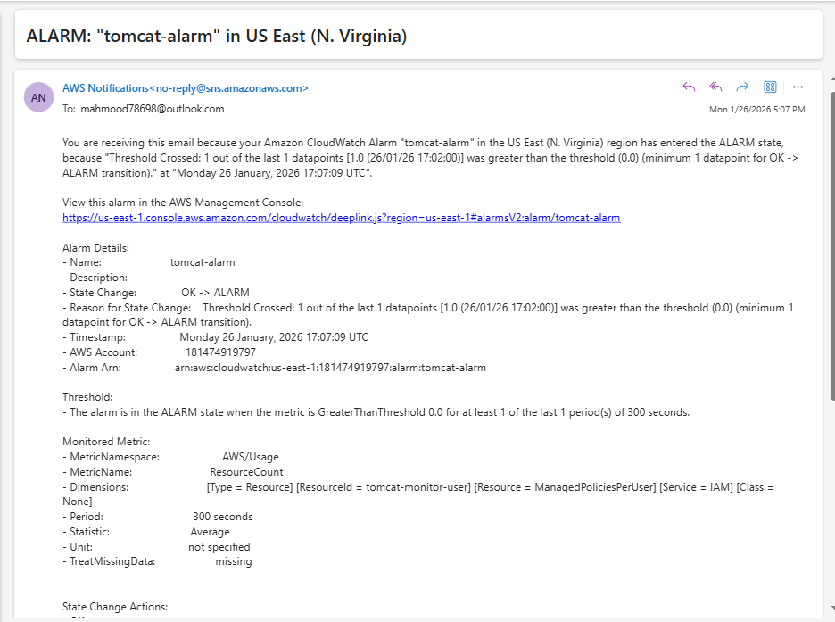
* Create a Dashboard and monitor the Nginx service to send the alert if Nginx is not running  
  First we need to install the amazon-cloudwatch-agent  
  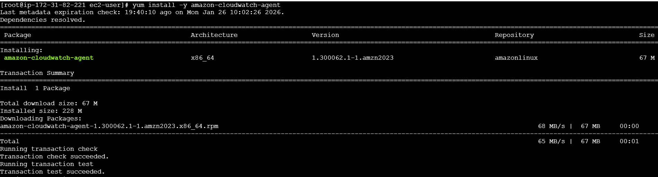  
  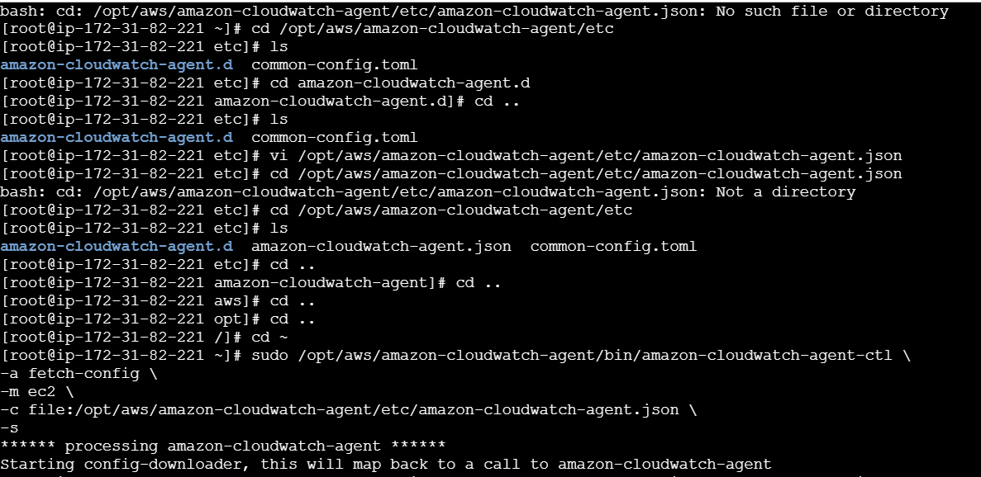  
  Install nignix  
  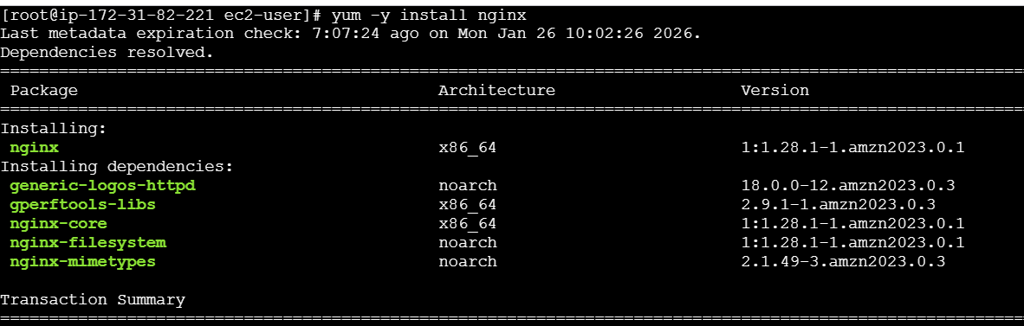  
  Then check nginx is running   
  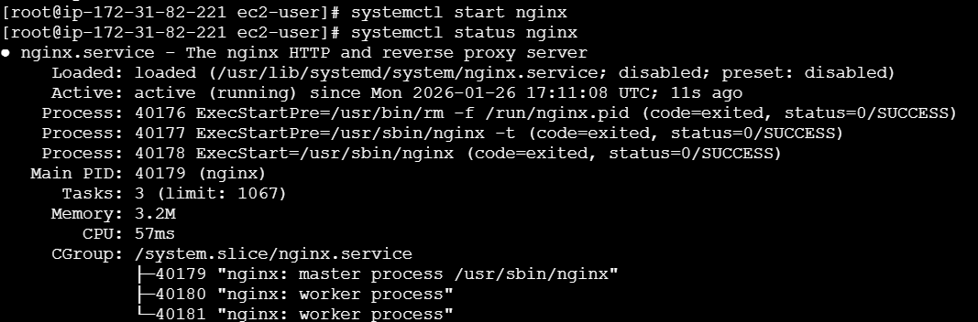

And add the nginx script then give permission   
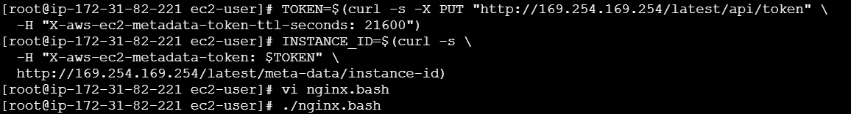  
Go to metrics   
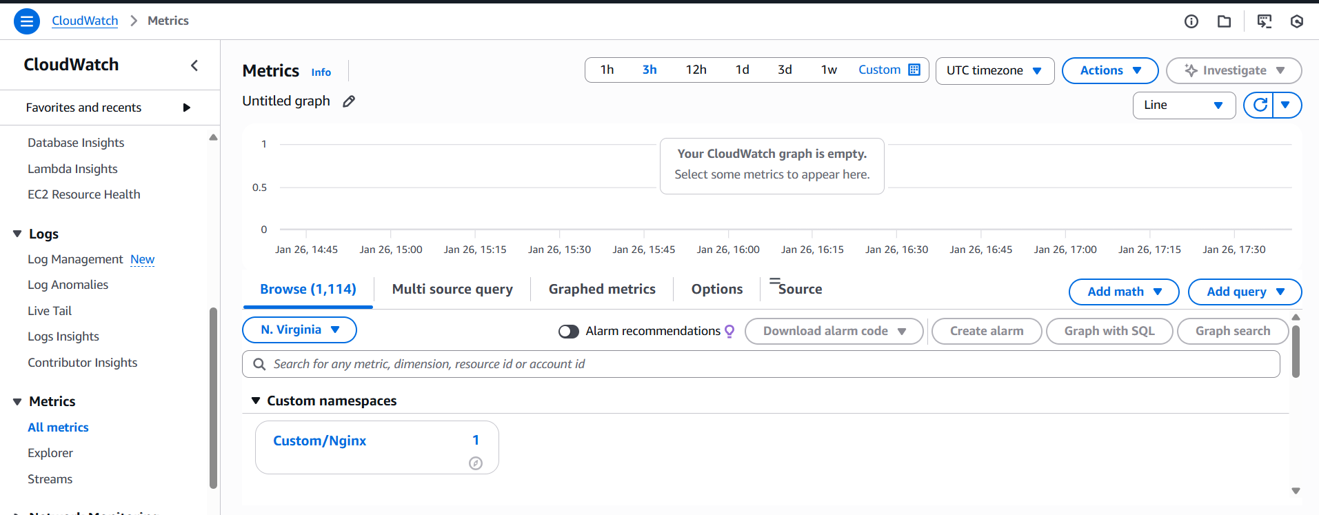  
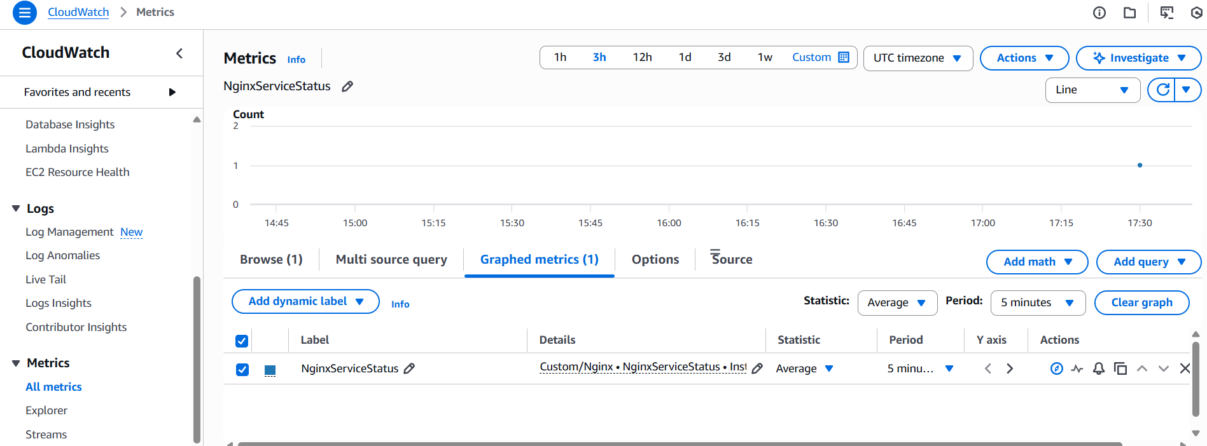  
  
Go to Dashboard and create a widgets  
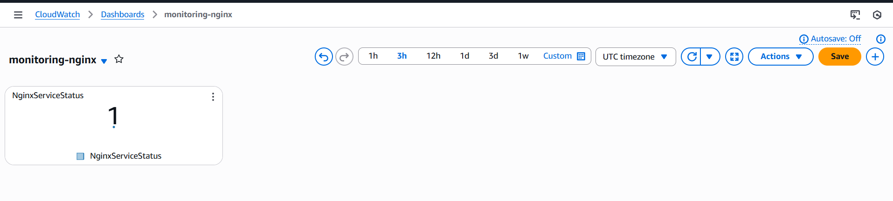  
Now we need to create an alarm  
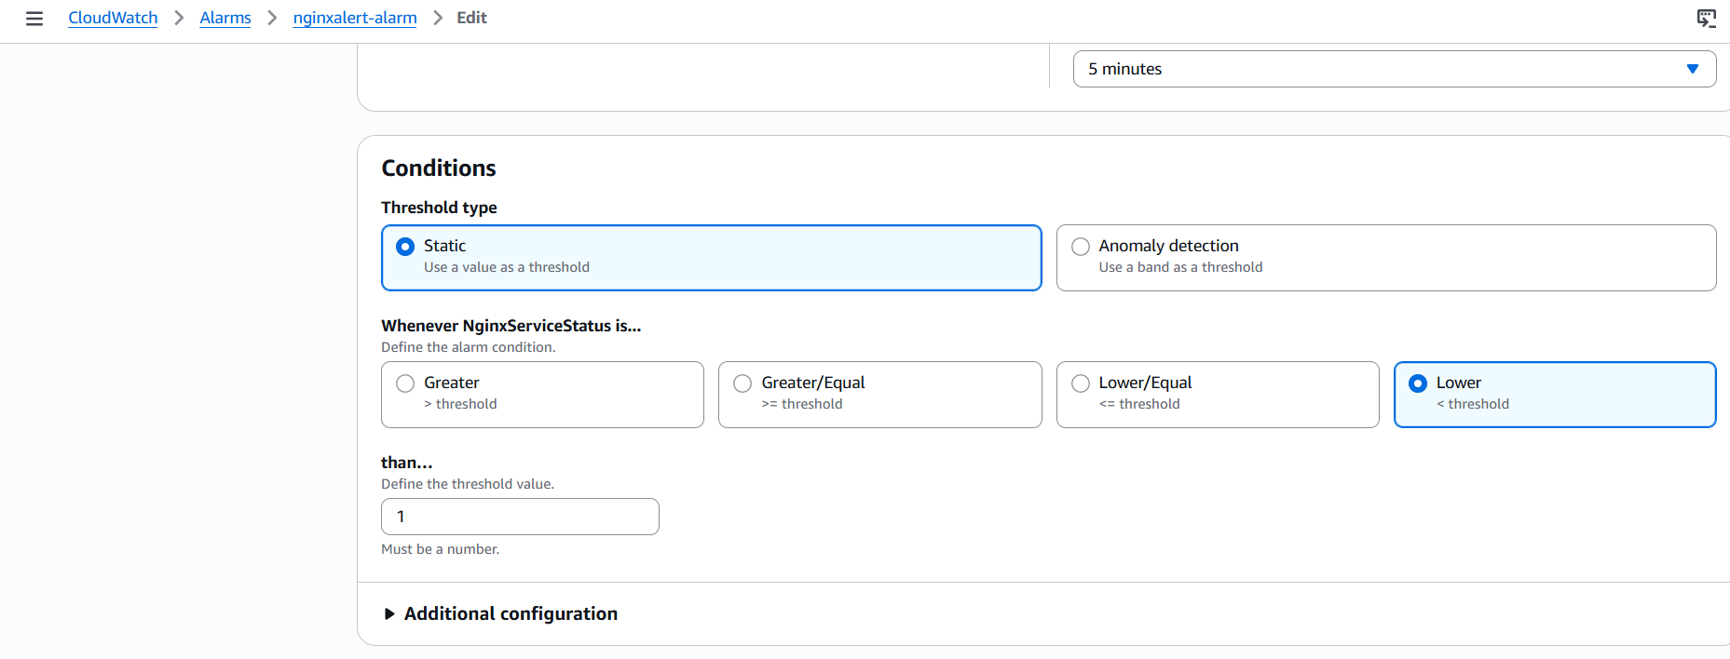  
after creating alarm we need to stop the nginx and with in a minute we will receive the email   
